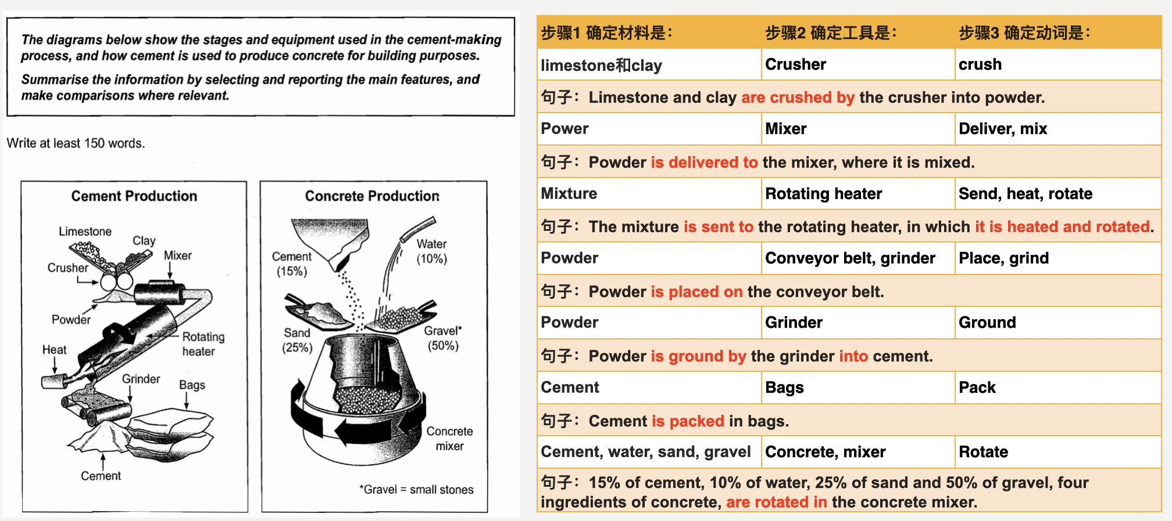

具体写法，可以参考下面的范文：

The two diagrams show how cement and concrete are produced with different materials and facilities used.

Overall, cement production consists of 4 stages, starting from crushing materials into powder and ending at bagging cement. In contrast, concrete production is simple, mixing four materials.

At the first stage, limestone and clay are crushed by the crusher into powder. The powder is then delivered to the mixer, where it is mixed. The mixture is subsequently sent to the rotating heater, after which it is heated and rotated. In the next step, the rotated powder is placed on the conveyor belt, before being ground by the grinder into cement. This final product is packed in bags.

In the process of the concrete production, gravel accounts for 50% of materials, while cement, water and sand represent 15%, 10% and 25% respectively. These materials are placed in the concrete mixer, which rotates clockwise until concrete is produced.

(~words)

